Uji Normalitas gambar

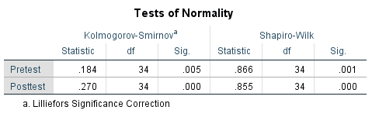
Tabel Jelas :

Tests of Normality
 | Kolmogorov-Smirnovaª |  |  | Shapiro-Wilk
 | Statistic | df | Sig. | Statistic | df | Sig.
Pretest | .184 | 34 | .005 | .866 | 34 | .001
Posttest | .270 | 34 | .000 | .855 | 34 | .000
a Lilliefors Significance Correction

Wilcoxon gambar
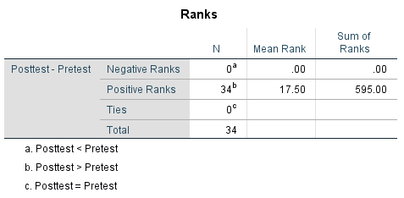
Tabel Jelas : Ranks
 |  |  | N | Mean Rank | Sum of Ranks
Posttest-Pretest |  | Negative Ranks | 0ª | .00 | .00
 |  | Positive Ranks | 34^{b} | 17.50 | 595.00
 |  | Ties | 0^{c}
 |  | Total | 34
a. Posttest < Pretest
b. Posttest > Pretest
c. Posttest = Pretest

Wilcoxon
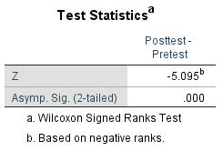
Tabel Hasil N-Gain Pretest dan Posttest
No. | Peserta Didik | Nilai pretest | Nilai Posttest | N-Gain | Kategori
1. | PD 1 | 33 | 86 | 0,79 | Tinggi
2. | PD 2 | 26 | 86 | 0,81 | Tinggi
3. | PD 3 | 33 | 80 | 0,70 | Tinggi
4. | PD 4 | 46 | 100 | 1 | Tinggi
5. | PD 5 | 46 | 86 | 0,74 | Tinggi
6. | PD 6 | 20 | 80 | 0,75 | Tinggi
7. | PD 7 | 20 | 86 | 0,82 | Tinggi
8. | PD 8 | 26 | 93 | 0,90 | Tinggi
9. | PD 9 | 46 | 93 | 0,87 | Tinggi
10. | PD 10 | 26 | 86 | 0,81 | Tinggi
11. | PD 11 | 40 | 80 | 0,66 | Sedang
12. | PD 12 | 46 | 100 | 1 | Tinggi
13. | PD 13 | 26 | 93 | 0,90 | Tinggi
14. | PD 14 | 46 | 93 | 0,87 | Tinggi
15. | PD 15 | 0 | 86 | 0,86 | Tinggi
16. | PD 16 | 33 | 86 | 0,79 | Tinggi
17. | PD 17 | 26 | 86 | 0,81 | Tinggi
18. | PD 18 | 20 | 100 | 1 | Tinggi
19. | PD 19 | 0 | 80 | 0,80 | Tinggi
20. | PD 20 | 20 | 86 | 0,82 | Tinggi
21. | PD 21 | 26 | 80 | 0,72 | Tinggi
22. | PD 22 | 46 | 93 | 0,87 | Tinggi
23. | PD 23 | 33 | 86 | 0,79 | Tinggi
24. | PD 24 | 46 | 80 | 0,62 | Sedang
25. | PD 25 | 33 | 80 | 0,70 | Tinggi
26. | PD 26 | 46 | 100 | 1 | Tinggi
27. | PD 27 | 46 | 93 | 0,87 | Tinggi
28. | PD 28 | 0 | 86 | 0,86 | Tinggi
29. | PD 29 | 20 | 86 | 0,82 | Tinggi
30. | PD 30 | 33 | 86 | 0,79 | Tinggi
31. | PD 31 | 46 | 100 | 1 | Tinggi
32. | PD 32 | 33 | 86 | 0,79 | Tinggi
33. | PD 33 | 46 | 80 | 0,62 | Sedang
34. | PD 34 | 20 | 93 | 0,91 | Tinggi

