THE TREND OF MULTIMODAL USE IN SCHOOL LEARNING FROM THE PAST TO THE FUTURE? A SYSTEMATIC LITERATURE REVIEW

1* Dyah Worowirastri Ekowati, 2Husamah, 3Rina Wahyu Setyaningrum, 4Puji Sumarsono
1 Department of Primary Teacher Education, Faculty of Teacher Training and Education, Universitas Muhammadiyah Malang, Indonesia
2Department of Biology Education, Faculty of Teacher Training and Education, Universitas Muhammadiyah Malang, Indonesia
3English Language Education Department, Faculty of Teacher Training and Education, Universitas Muhammadiyah Malang, Indonesia
4Teaching English As A Second Language, Faculty of Language and Communication, Sultan Idris Education University, Malaysia
*Corresponding Author e-mail: worowirastri@umm.ac.id
Abstract: In school learning, multimodality is the integration of various written, spoken, hand-arm-finger movements, facial expressions, images, artifacts, and concrete objects to create meaning and enhance communication while learning. The focus of researchers on the theme of multimodality in school learning is highly expected, as evidenced by publications in reputable journals. The purpose of the systematic literature review (SLR) is to review and compare research investigations on articles published by Scopus-indexed journals. We used the phrase "multimodality AND learning AND school" in the disbursement menu in the Scopus database, and found 1251 articles. Furthermore, 19 articles were obtained that met the criteria for analysis. The inclusion and exclusion model used was PRISMA. A total of 19 articles conducted research using the most dominant approach, namely a qualitative approach of 73.68% followed by a mixed and quantitative approach. The main keywords that often appear using the VOSviewer application are multimodality, learning, school, and literacy. Related keywords that do not have a direct relationship with multimodality are digital media, media literacy, school, creativity, and cyberspace. This is an opportunity for future research. Regarding the country of origin of the authors, most are from Australia, namely 5 articles. The dominant articles were written through collaboration between two authors (47.36%) and have the status of collaboration between universities in one country. The results of the analysis using VOSviewer on the 19 articles showed that Neil Mercer had the most publications cited by other articles. The analysis of the 19 articles illustrates that the most frequent contribution is the development of learning materials, both virtual and non-virtual, using various media, ranging from manual to smartphones. We then successfully discussed and formulated these results regarding future opportunities related to multimodal learning in schools. These findings can be used as a consideration or basis for researchers to study multimodal themes in learning in schools according to their respective backgrounds and objectives. | Article History  Received: 2  Revised:  Published:.. 2017  Key Words :  Multimodal, Learning School, Systematic literature review
How to Cite: Dyah Worowirastri Ekowati, Husamah, Rina Wahyu Setyaningrum, Puji Sumarsono (2024). The trend of multimodal use in school learning from the past to the future? A systematic literature review. Jurnal Kependidikan: Jurnal Hasil Penelitian dan Kajian Kepustakaan di Bidang Pendidikan, Pengajaran dan Pembelajaran, vol(no). doi:https://doi.org/10.33394/jk.vxxyyi
 https://doi.org/10.33394/jk.vxxyyi | This is an open-access article under the CC-BY-SA License.


Introduction
In education, written learning evaluation is one of the most commonly used evaluation methods. By applying such evaluation, teachers can use student’s written responses to measure their potential and understanding during the teaching and learning process (Daniel, 2016; Danielsson & Selander, 2021). A written response is defined as the words or notes written on a paper (Hodge et al., 2019; Wu & Fitzgerald, 2021), usually in the form of a sentence, paragraph, and document gained from the results of information search, text analysis, information extraction, categorization, visualization, technology, and learning results (Liu et al., 2017; Tan, 2011).
In the last decade, several studies have reported that evaluation can be carried out by analyzing the response and anything written on the paper (Bezemer & Kress, 2020; Liu et al., 2017; Minaee et al., 2020; Tan, 2011). However, the evaluation can also be performed by analyzing students' learning understanding through images, video activities, experiments, speeches, and shoulder-hands-fingers movements (Archer et al., 2021; Barton et al., 2021; Unsworth & Mills, 2020). In light of the COVID-19 outbreak, educators have employed pictures, video activities, experiments, interviews, spoken and other forms of responses except the written ones as the main options to conduct learning evaluation processes (Ekowati & Suwandayani, 2021; Zarate & Medina, 2021). This results from classroom learning that has integrated and maximized various student resources. This integration potentially allows a learning evaluation that combines written responses, spoken responses, the movements of hands-arms-fingers (gesture), facial expressions, images (Maulida et al., 2024), artifacts, and concrete objects called multimodal (Danielsson & Selander, 2021; Kozhemyakin & Lovyagina, 2020).
Students who use multimodal learning can improve their comprehension, ability to evaluate, and mastery of the course topics. Multimodal also refers to the use of various learning modes or media to assist students with their understanding and communication skills improvement. Applying multimodal learning has some benefits, such as a) using a variety of interactional modes and media to increase students' participation in the learning and instruction process; This might help teachers keep the student’s motivation and interest during the teaching and learning process; b) improving understanding and integrating various resources to assist students in comprehending and analyzing the materials; c) inclusivity: implementing multimodal can help teachers fulfill the variety of students’ needs by providing several ways to access and interact with learning materials; d) flexibility: multimodal can be suited to various learning styles and choices (Mahler et al., 2018). Students can choose a certain way that suits them best; e) real-life relevance: multimodal reflects information found in real-life settings. This can prepare students to face the 21st century's labor market demands. Therefore, using multimodal learning can help students improve their involvement and understanding, support inclusivity, provide flexibility, and reflect on the relevance of the real-life setting (Abe, 2020; Shazly, 2021).
Using multimodal, students can communicate their understanding in various ways (Moreno-Morilla et al., 2021). Several research discovered that communication in learning can be done through video activities, interview recordings, student movements, and others (Kaindl, 2019; Olteanu, 2019; Yang, 2019; Zhang & Cassany, 2021). The different ways of communication sometimes give different meanings. At a particular moment, the spoken response can go against the information delivered by another medium, such as a written response or body movement (Brazgovskaya, 2019; K A Mills & Brown, 2022). In another moment, each way gives mutual support that completes each other (Danielsson & Selander, 2021; Unsworth, 2021). Hence, multimodal integration becomes an essential part of education. The functions of multimodal education should be thoroughly examined because of their significance in the process of instruction and study in schools.
Browsing the articles in the Scopus database using the keywords “literature review multimodal” there were six articles. Five articles focus on multimodal topics applied in the fields beyond education. Their main topic is the diagnosis and medication in the field of medicine (Değer et al., 2022; Karaca et al., 2014; Kölln, 2010; Loos et al., 2009; Rickmann et al., 2020). Only one article focuses on education, talking about the contribution of TIME magazine in visualizing and communicating the ideas in education between 1923 and 2019. The article discusses some theories on visual art development and the semiotic approach in multimodal used to analyze 115 TIME magazine covers with education and school themes using content analysis (Kachorsky et al., 2020). However, the Scopus database has not published any article on multimodal learning in school that discusses the learner’s ability, material development, learning strategy, facility, curriculum development, and teacher resource development (Zuhri et al., 2024). This explains why the multimodal components of learning at school have not been the subject of any Systematic Literature Reviews (SLRs). SLR's goal is to conduct an in-depth analysis and comparison of articles on multimodal learning in the classroom that are indexed in the database of Scopus.
SLR is projected to help in the growth of the research on multimodal learning in the classroom, which may serve as a resource for scholars and readers with an interest in this topic. It focuses on the original article's publication, which explored a topic related to multimodal learning in the classroom that other scholars had not looked at so that it can serve as a baseline study and a pillar for deciding how multimodal research will go in the future. The information's scope was limited to describing the research's emphasis and inclination toward this subject in the original article. We discussed the topic of multimodal instruction in school, which may serve as a resource for professionals, educators, decision-makers, and the general public.

Research Method (12pt, Times New Roman)
This SLR study was carried out in-depth to find, evaluate, and examine the works on multimodal instruction in the classroom. This type of research is done by performing in-depth analysis (Ekowati et al., 2023; Hennessy et al., 2020). The findings of SLR offer a concise overview of the direction and impact of multimodal research in education, as well as prospects that are explored through methodical and transparent approaches to addressing research problems (Ekowati et al., 2024). Therefore, questions of research describe a clear scope of research focus. The research questions are: (1) How is the publication trend of the “multimodal learning in school” topic in journals indexed by Scopus? (2) How does the concept of “multimodal learning in school” contribute and its future opportunity?
This research used the keywords “multimodal AND learning AND school” in the Scopus database. We performed an in-depth search for articles until April 2024. The Mendeley reference manager was synced with the data search results, which were recorded in *CSV and *RIS formats. We used VOSviewer software to present the data more clearly, interestingly, and effectively. The Scopus article search history comprises TITLE-ABS-KEY TITLE-ABS-KEY (multimodal AND learning AND school) AND (LIMITTO (SUBJAREA, "SOCI")) AND (LIMIT-TO (DOCTYPE, "ar")) AND (LIMITTO (EXACTKEYWORD, "Multimodal") OR LIMITTO (EXACTKEYWORD, "Multimodal Learning") OR LIMITTO (EXACTKEYWORD, "School")) AND (LIMITTO (LANGUAGE, "English")) AND (LIMIT-TO (OA, "all")). By using the keywords, 1251 articles were located. We performed exclusion and inclusion using the Preferred Reporting Items for Systematic Reviews and Meta-Analysis (PRISMA) approach to get relevant publications. This PRISMA model corresponds to (Gallagher et al., 2016) and is widely employed by several writers who have released their SLR articles (Ekowati et al., 2023). Some essential notes that can be used as the fundamental inclusion criteria of SLR are (1) the subject area should be “Social Sciences”; (2) Original and research papers should be included in publications; (3) English should be the language of writing for articles; (4) open access articles should to be available; and (5) It is recommended to filter the articles using the keywords "multimodal," "multimodal learning," and "school." Figure 1 displays the inclusion and exclusion criteria for this study.
Figure 1 displays that 1251 items were found in the first search. From then, the publications were sorted by topic matter within the social sciences, resulting in 843 articles. This indicates that 403 articles did not fall into this criterion. Next, we used the article criterion, and we gained 616 articles. From that number, 227 articles were conference papers, book chapters, reviews, books, conference reviews, notes, letters, and erratum are not included.
The next action was to look for articles with the terms “multimodal”, “multimodal learning”, and “school” and eliminated the keywords of multimodality, learning, education, human, literacy, humas, students, multiliteracies, teaching, writing, multimodality literacy, curriculum, translanguaging, social semiotics, female, digital storytelling, collaborative learning, identity, digital technologies, medical educations, male, article, science education, reading, procedures, pedagogy, new literacies, multi-modal, medical student, technology, students, medical, e-learning, digital/media literacies, critical literacy, collaboration, child, teacher education, semiotics, online learning, mathematics, english language learners, digital literacy, design, assessment, 4-adolescence, primary school, new literacies, digital/media literacies, multi-modality, instructional strategies, clinical competence, sociocultural, questionnaire, multimodal texts, multimodal data, multimodal composition, multimodal analysis, multilingualism, multi-modal learning, medical school, linguistics, language learning, human experiment, genre, education, medical, undergraduate, early childhood, digital media, conversation analysis, content literacy, classroom interaction, virtual reality, school, program evaluation, multimodal representations, multimodal learning analytics, multiliteracies pedagogy, literature, language learners, instructional strategies, methods, materials, human computer interaction, embodied learning, case study, augmented reality, 3-early adolescence, 2-childhood, visual literacy, digital/media literacies, visual literacy, united states, transduction, surveys and questionnaires, social media, representation, reading comprehension, qualitative, research methodology, psychology, professional development, primary education, popular culture, narrative, multi-modal interactions, motivation/engagement, motivation, methods, media literacy, meaning-making, machine learning, literacy practices, literacies, learning system, language therapy, language development disorders, intellectuality, inclusive education, high school, funds of knowledge, ethnography, emotion, elementary education, electrodermal activity, educational measurement, early childhood education, drawing, discourse, digital stories, digital resources, digital multimodal composing, digital literacies, computer aided instruction, comprehension, comparative study, children, bilingual education, and materials, agency, affordances, adult, adolescents, adolescence, engagement, emergent bilinguals, early years, discourse analysis, disciplinary literacy, digitalization, digital learning, digital, design for learning, decision making, controlled study, content area literacy, content analysis, connected learning, computational thinking, communication, children’s voices, case study; research methodology, affect, adolescent, adaptation. 42 articles were found in this step, while 574 did not count.
In the next step, 42 articles written in English were selected using an open-access filter, and 19 publications fulfilled the criterion in the results. This indicates that 23 items were not included.

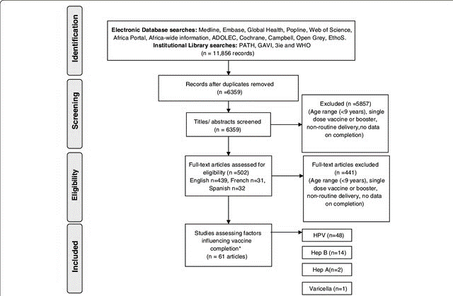
Use the keywords "multimodal" AND "multimodal learning" AND "school" to narrow your search depending on the compatibility of the abstract and full text (n =42)
Excluded ( n = 574)
We don’t include multimodality, learning, education, human, literacy, humas, students, multiliteracies, teaching, writing, multimodality literacy, curriculum, transluaging, social semiotics, female, digital storytelling, collaborative learning, identity, digital technologies, medical educations, male, article, science education, reading, procedures, pedagogy, new literacies, multi-modal, medical student, technology, students, medical, e-learning, digital/media literacies, critical literacy, collaboration, child, teacher education, semiotics, online learning, mathematics, english language learners, digital literacy, design, asessment, 4-adolescence, primary school, new literacies, digital/media literacies, multi-modality, instructional strategies, clinical competence, sociocultural, questionnaire, multimodal texts, multimodal data, multimodal composition, multimodal analysis, multilingualism, multi-modal learning, medical school, linguistics, language learning, human experiment, genre, education, mediacla, undergraduate, early chilhood, digital media, conversation analysis, content literacy, classroom interaction, virtual reality, school, program evaluation, multimodal representations, multimodal learning analytics, multiliteracies pedagogy, literature, language learners, instructional strategies, methods, materials, human computer interaction, embodied learning, case study, augmented reality, 3-early adolescence, 2-childhood, visual literacy, digital/media literacies, visual literacy, united states, transduction, surveys and questionnaries, social media, representation, reading comprehension, qualitative, research methodology, psycology, profesional development, primary education, popular culture, narrative, multi-modal interactions, motivation/engagement, motivation, methods, media literacy, meaning-making, machine learning, litearcy practices, literacies, learning system, language therapy, language development disorders, intelextuality, inclusive education, high school, funds of knowledge, etnography, emotion, elementary education, electrodermal activity, educational measurement, early chilhood education, drwaing, discourse, digital stories, digital resources, digital multimodal composing, digital literacies, computer aided instruction, comprehension, comparative study, children, bilingual education, and materials, agency, affordances, adult, adolencets, adolescence, engagment, emergent bilinguals, early years, discourcee analysis, disciplinary literacy, digitalization, digital learning, digital, design for learning, decision making, controlled study, content area literacy, content analysis, connected learning, computational thinking, communication, children’s voices, case study; research methodology, affect, adolescent, adaptation
Searching electronic databases using Scopus
Document search terms: multimodal, learning, and school (n = 1251)
Social sciences (n= 843)
Article (n= 616)
English-language article (n= 42)
We don't have German or Spanish, excluded (n = 0)
Excluded (n = 227)
Conference papers, book chapters, reviews, books, conference reviews, notes, letters, and erratum are not included.
Excluded (n =408)
We skip to include Computer Science, Humanities and Art, Medicine, Psychology, Enginering, mathematics, neuroscience, health professions, business, environmental science, management and accounting, pharmacology, toxicology and pharmaceutics, decision sciences, genetics and molecular biology, biochemistry, physics and astronomy, nursing, economics and finance, materials science, chemistry, multidisciplinary, energy, earth and planetary sciences, undefined, chemical engineering, agricultural and biological sciences, vetenirary, immunology and microbilogy, dentistry
Open Access (n=19)
Excluded (n=23) Gold, hybrid gold, bronze, and green articles are not included

Figure 1. A Diagram for A Systematic Review Utilizing the PRISMA Model

Result and Discussion
The results and discussion are explained to answer the publication trends and the contribution of the concept of "multimodal learning in schools" and its opportunities in the future. The results and discussion are explained based on year distribution, research types, keywords, document by country, collaboration category, co-citation, and research contribution.

Year Distribution
Figure 2 illustrates the number of papers published annually from 2010 to 2023 to the year distribution. Figure 2 shows the number of publications on multimedia learning in schools yearly. From 2010 to 2014, only one article with this theme was published. Even though there was a decline in 2017, it continued to increase in the following year. There was a rising trend of publications from 2014 to 2023. The peak was in 2023 when four articles were issued with the possibility of additional publications. The possibility happened because the data search was conducted only in April 2024, so the number might gradually rise if the search continues until December 2024.
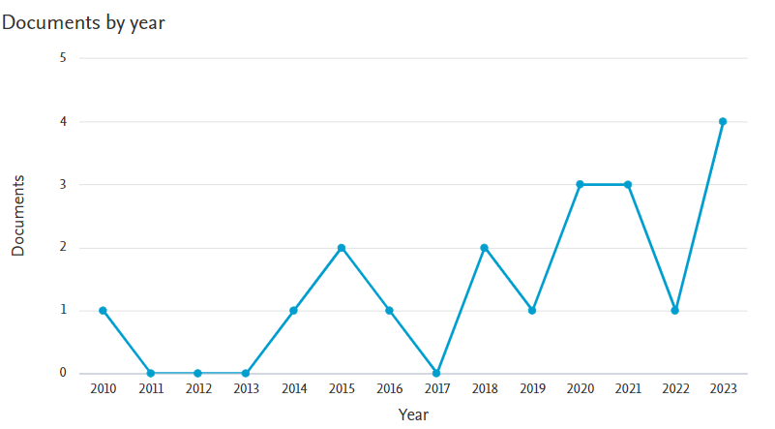
Figure 2. The Articles' Distribution Year

Research on multimodal learning in school has been identified since 2010. In the first five years, the amount of research on this matter was low, while the period from 2014 to 2023 saw a significant rise. The rising number of publications could happen due to several factors, one of which was the use of multimodal learning in school. Some recent studies in education underlined the expanding concepts of answering. Students nowadays use various means of communication to answer questions, such as written answers integrated with illustrations or videos or spoken responses incorporated with body movements (Lustig et al., 2021).
How students answer the question would be expanded into multimodal, It has a range of semiotic materials, including words and diagrams, coding systems, graphics, images, or multiple symbols, written answers, visual images, body movements, postures, movements, voices, or silences (Danielsson & Selander, 2021; K A Mills & Doyle, 2019; Ngiam et al., 2011). Using multimodal, someone can communicate with various means. Multimodal can represent things differently (Moreno-Morilla et al., 2021). Each part of a student’s answer can potentially bring meaning in a certain way. However, To adequately describe and record how all new resources are made to have situational significance, multimodal frameworks must be developed (Adami & Swanwick, 2019). This phenomenon should be studied further.

Research Types
Three research types could be identified after examining these 19 articles, as stated in Table 1. Table 1 indicates that the most favored research type was qualitative, with 73.68%, followed by mixed method and quantitative, with 15.79% and 10.52%, respectively. Qualitative research design is the most dominant research type on multimodal learning in school. This might happen since multimodal learning in school focuses on the resources people use to define, understand, and express themselves (Alvarez et al., 2021). This situation requires qualitative analysis (Reid & Moses, 2020; Serafini & Reid, 2019). A qualitative approach is required since it can explore the great potential of the multimodal of each student (Cun, 2021; Davidson et al., 2019; Komarawan, 2019; Machin & Chen, 2021; Maier & Ravazzani, 2019; Reid & Moses, 2020; Undheim & Hoel, 2021).
Table 1. Research Types on Multimodal Learning in School
No | Research Types | Amount | References
1 | Qualitative | 14 | (Barman & Kjällander, 2022; Georgina Barton & Le, 2023; Berger & Zezulkova, 2018; DeJaynes, 2015; Aleksandr Fadeev, 2020; Hodge et al., 2019; Kachorsky et al., 2020; Kajamaa & Kumpulainen, 2020; Kathy A. Mills, 2010; Sánchez-López et al., 2021; Tytler et al., 2023; Wang & Tan, 2023; Wernholm & Reneland-Forsman, 2019; Wiklund-Engblom et al., 2014)
2 | Mix-method | 3 | (Gordon et al., 2016; Taylor & Clarke, 2021; Zwitserlood et al., 2015)
3 | Quantitative | 2 | (Gadille et al., 2021; Pazaer & Assaiqeli, 2023)
The next type of research applied by the authors was the mixed method (Gordon et al., 2016; Taylor & Clarke, 2021; Zwitserlood et al., 2015). The multimodal relationship was fully shown by combining qualitative and quantitative methods. Qualitative analysis primarily focuses on student resources (Chen, 2016). Regarding quantitative testing, the authors conducted several statistical analyses on the studied indicators (Debras, 2021; Gualberto & dos Santos, 2019; Taylor & Clarke, 2021). Testing in this context is that the combination of these approaches would help the authors gain information about the obstacles and how to solve them. Authors can benefit from additional research that explains how researchers conduct complex mixed-method approaches to study multimodal (Creswell, 2012; Creswell & Clark, 2018). Three articles applied the mixed method. This means there is an excellent opportunity for future researchers to conduct further research using this approach. Next, the authors also applied a quantitative approach. The authors conducted a test using SPSS. The quantitative analysis tests the variables involved in the research (Debras, 2021; Gualberto & dos Santos, 2019; Potapova et al., 2019). However, very few researchers have applied this approach to study multimodal. On the other hand, we cannot find any research applying the approaches of research and development and case studies. Hence, it is a terrific opportunity for future researchers to apply research and development and case study approaches.

Keywords
Figure 3 below illustrates the keyword trends used mainly by the authors when writing articles with the theme of multimodal learning in school. Figure 3 shows four main keywords frequently appearing and having mutual relations: multimodal, learning, school, and literacy. These keywords were gained using the VOSviewer application, which stated that co-occurrence—the minimum number of keywords occurrence is one—was 55 keywords. The top four keywords were multimodal, learning, school, and literacy. These keywords showed that multimodal had no direct relationships with digital media, media literacy, school, creativity, and the virtual world.
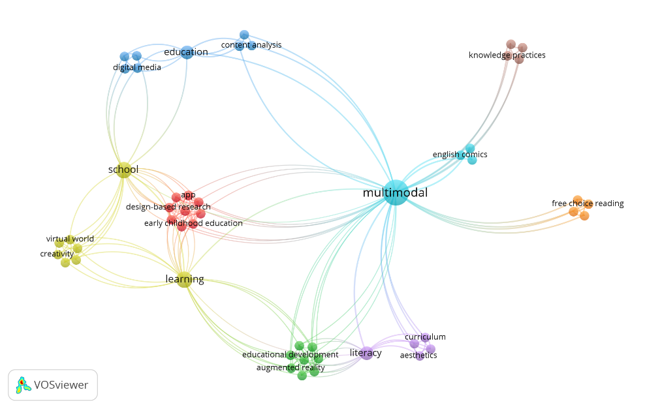
Figure 3. The Trends of Keywords in Research on Multimodal Learning in School

Information on research gaps was gained based on keyword analysis of the 19 articles using the VOSviewer application. First, very few research identified that multimodal keywords are directly connected to digital media. Digital media is a medium that has rapidly developed during the 21st century. This media combines texts, data, images, and voices stored in digital format. Digital media enables teachers and students to see, modify, listen, distribute, and store data digitally (Lestari, 2018; Papadopoulou, 2019). It includes advertisements, songs, videos, podcasts, or audiobooks. This also can be a good opportunity for future researchers since, during the pandemic, schools and learners have made themselves familiar with digital media for learning (Chung & Huang, 2022; Herath et al., 2021).
Second, we could not find any research on multimodal using the school keyword. The school itself is the student’s learning place, concerned with the fundamental needs of communication. Even the 21st-century learning ability declares that communication is one of the main competencies (Kozhemyakin & Lovyagina, 2020; Mabena et al., 2021). The multimodal in school creates meaning from texts, voices, written texts, videos, artifacts, and other resources to improve communication (Graham & Luttrell, 2019; Kozhemyakin & Lovyagina, 2020). In the development of school learning, research on the use of multimodal learning in school and the mutual connection between them might be potential future research.
Third, multimodal research directly related to creativity was also rarely identified. It is worth knowing that one of the main competencies of 21st-century learning is creativity. The student’s ability to create new things or products or new ways to solve an existing problem is the definition of creativity. Meanwhile, using multimodal learning might help students understand and analyze the situation and condition and can improve their problem-solving ability (Fernández-Fontecha et al., 2019; Ke & M. Clark, 2020). Therefore, research with the keywords of multimodal and creativity can be a good opportunity for future researchers.
Fourth, these 19 articles stated that multimodal research in virtual worlds was rarely conducted. The virtual world is a virtual environment used to interact at a particular time (Allahmoradi, 2018; K A Mills & Brown, 2022). The virtual world occurs on simulations, games, and other social platforms (Ke & M. Clark, 2020; Palombi & Toti, 2017). Some examples of frequently used virtual world platforms are Second Life, Minecraft, and Sand Box. On the other hand, one of the benefits of multimodal is the flexibility principle. Multimodal suits each student’s unique learning styles and preferences. The 21st-century students have the freedom to choose and decide the most suitable resources for them (Iturriaga & Young, 2021; Smith, 2018; Xu et al., 2021). The learning product in the form of the artifact is not only concrete but also virtual (Bock & Dimmel, 2021; Plass & Kaplan, 2016; ul Sabah et al., 2020). This could also be an excellent opportunity for the researchers to conduct further studies.

Document by Country
Figure 4 presents the document information identified as the authors’ home country. In terms of research articles published on multimodal learning in schools, Australia led the world, with five articles. The second country was the United Kingdom, which had three articles. The next place was held by three countries, Finland, Sweden, and the United States, with two articles each. The rest were Brazil, the Czech Republic, Estonia, France, and Indonesia, with each publishing an article.
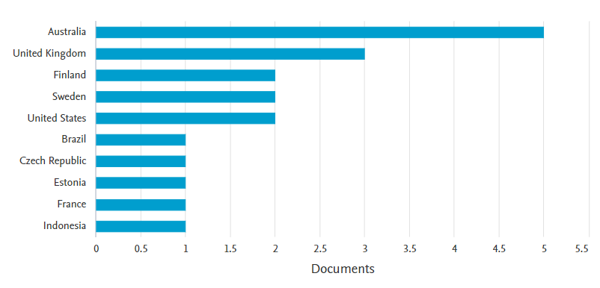
Figure 4. Document by Country

The following information related to the continents from which the authors came is given in Table 2.
Table 2. The Multimodal Approach to Learning the Home Country and Continent of Authors
No | Country | Continent | Amount | Article
1 | Australia | Australia | 5 | (Georgina Barton & Le, 2023; Gordon et al., 2016; Kathy A. Mills, 2010; Tytler et al., 2023; Wang & Tan, 2023)
2 | United Kingdom | Europe | 3 | (Pazaer & Assaiqeli, 2023; Taylor & Clarke, 2021; Zwitserlood et al., 2015)
3 | Finland | Europe | 2 | (Kajamaa & Kumpulainen, 2020; Wiklund-Engblom et al., 2014)
4 | Sweden | Europe | 2 | (Barman & Kjällander, 2022; Wernholm & Reneland-Forsman, 2019)
5 | United States | America | 2 | (DeJaynes, 2015; Kachorsky et al., 2020)
6 | Brazil | America | 1 | (Sánchez-López et al., 2021)
7 | Czech Republic | Europe | 1 | (Berger & Zezulkova, 2018)
8 | Estonia | Europe | 1 | (A Fadeev, 2020)
9 | France | Europe | 1 | (Gadille et al., 2021)
10 | Indonesia | Asia | 1 | (Januarty & Nima, 2018)

Australia has recorded the highest number of research on multimodal learning in schools. It needs to be known that the curriculum applied in Australia has had direct references to multimodal communication channels, such as spoken or written language (Exley & Mills, 2012), as shown in Figure 5.
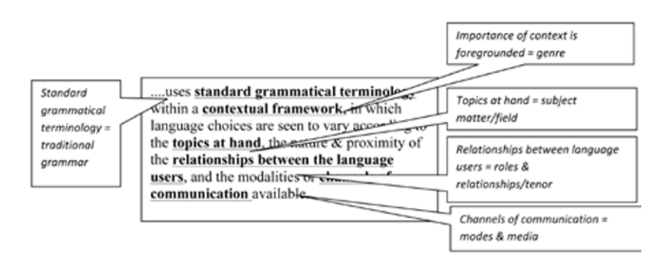
Figure 5. The references in the Australian curriculum which state multimodal as a means of communication (Exley & Mills, 2012)

The references in the curriculum are interesting since they have three systems of meaning, they are tenor, mode, and field. The field is related to the lessons learned or the themes covered in that work. Tenor describes the ‘relationship between language users.’ Communication mode directly refers to ‘modality’ or communication mode used, such as spoken or written language. The emergence of modality in the Australian curriculum has become one of the beginnings of various research related to multimodal learning themes in schools. The following countries were Sweden and the United States. The next grouping is based on each author’s continent. The highest number of authors was from the European continent, with 44.44%. The second one was authors living in the Australian continent, with 27.78%. The next one is the American and Asian continents, with percentages of 16.67% and 11.11%, respectively. There was no research on multimodal learning written by authors living in Africa. This could be an excellent opportunity for authors residing in Africa.

Collaboration Category
Based on the result analysis of the author's number of those 19 articles, the number of authors working on each article was gained, as stated in Figure 6.
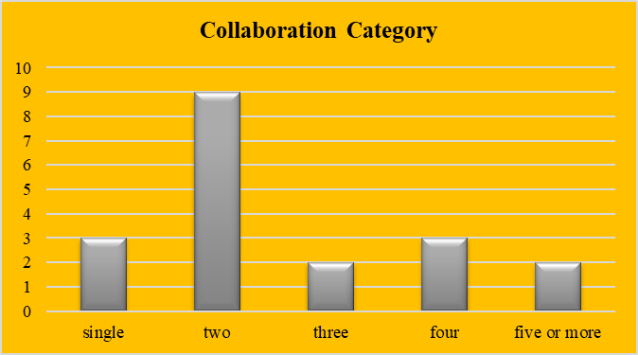
Figure 6. The Total Number of Writers for Each Article

Figure 6 shows that 47.36% of articles were written by two authors (Barman & Kjällander, 2022; Georgina Barton & Le, 2023; Berger & Zezulkova, 2018; Januarty & Nima, 2018; Kajamaa & Kumpulainen, 2020; Pazaer & Assaiqeli, 2023; Taylor & Clarke, 2021; Wang & Tan, 2023; Wernholm & Reneland-Forsman, 2019). The next one was the article written by a single author (DeJaynes, 2015; Aleksandr Fadeev, 2020; Kathy A. Mills, 2010) and four articles (Gadille et al., 2021; Gordon et al., 2016; Zwitserlood et al., 2015), with the same percentage of 15.78%. The percentage of articles written collaboratively by three authors (Kachorsky et al., 2020; Sánchez-López et al., 2021) and more than five authors (Tytler et al., 2023; Wiklund-Engblom et al., 2014) were the same at 10.52%. Based on this finding, it could be concluded that 84.21% of articles were written collaboratively. The categories of those 19 articles are stated in Figure 7.

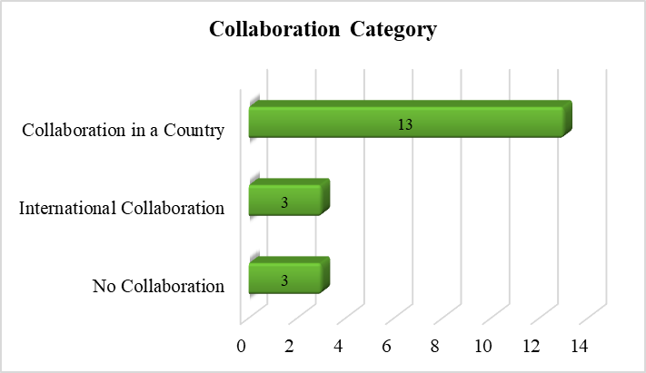
Figure 7. Collaboration Categories

The most frequent collaboration happened among fellow compatriots. On the other hand, the number of articles produced by international collaborations and single authors was the same. This means that the multimodal learning research was mainly carried out collaboratively among authors from the same country. This indicates an excellent opportunity in the future to conduct collaborative research with researchers from different countries or continents. This would also be an excellent opportunity to collaborate with researchers living in the African continent.
Figure 6 shows that 50% of articles are written by two authors (Barman & Kjällander, 2022; Georgina Barton & Le, 2023; Berger & Zezulkova, 2018; Januarty & Nima, 2018; Kajamaa & Kumpulainen, 2020; Pazaer & Assaiqeli, 2023; Taylor & Clarke, 2021; Wang & Tan, 2023; Wernholm & Reneland-Forsman, 2019). The following order is an article written by a single researcher (DeJaynes, 2015; Aleksandr Fadeev, 2020; Kathy A. Mills, 2010) and four authors (Gadille et al., 2021; Gordon et al., 2016; Zwitserlood et al., 2015). The next is the article written by three authors (Kachorsky et al., 2020; Sánchez-López et al., 2021) and more than five authors (Tytler et al., 2023) with percentages of 11% and 5%, respectively.
The most dominant collaboration happened among fellow citizens. On the other hand, the number of international collaborations and individual authors was the same. This means that research on multimodal learning was mostly collaboratively conducted by authors from the same country. There is an opportunity for future research collaboratively carried out by international and intercontinental researchers. There is also an opportunity to perform collaborative research with authors living in the African continent.

Co-citation
The co-citation of two or more articles on the topic of multimodal learning in schools was shown by the findings of the co-citation analysis performed on the 19 articles using VOSviewer. The co-citation information showed that the researcher referred the most by other authors was Neil Mercer, as shown in Figure 8.
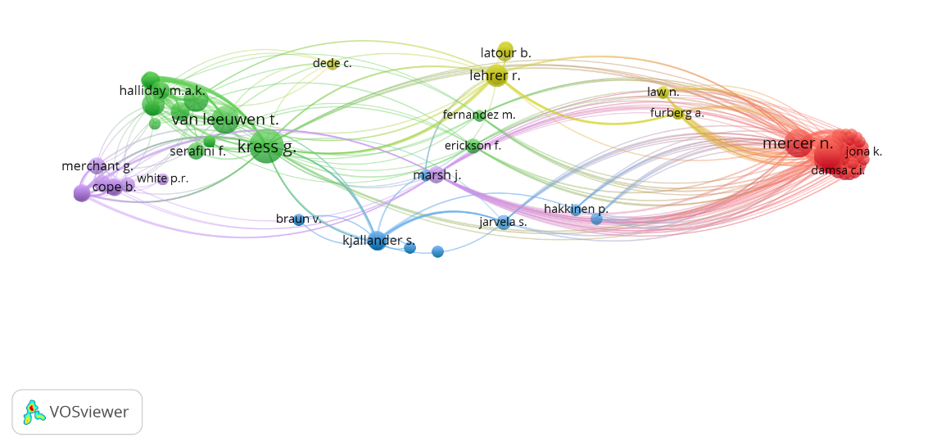
Figure 8. Result Analysis of Co-Citation
The results of the analysis using VOSviewer on the 19 articles showed that Neil Mercer had the highest number of publications cited by other articles. He is an Emeritus Professor at Cambridge University and the director of Cambridge Oracy. He chaired the Center for Language and Communication and the Center for Research in Education and Education Technology while he was an Open University language and communication professor (https://www.educ.cam.ac.uk/people/staff/mercer/).
He is also a psychologist who specializes in the functions of language in the classroom and the development of children’s thoughts (Kislitsyna & Chernyavskaya, 2020). He regularly participates in the professional development program for the regional governments and schools. One of his inventions is a learning method called Thinking Together, which he developed with Lyn Dawes, Karen Littleton, and Rupert Wegerif. This method has been proven to improve children’s communication, learning, and reasoning skills (Hennessy et al., 2020). Neil Mercer has worked as a consultant for some United Kingdom departments and educational institutions. His invention of Thinking Together has been incorporated into the National Strategy for Basic and Middle Education and integrated into the Teaching and Learning Toolkit made available by the Educational Endowment Foundation. He has published 105 articles from 1987 to 2023. In the last five years, his article entitled "Teacher–Student Dialogue During Classroom Teaching: Does It Impact on Student Outcomes?” has become the most cited article (Howe et al., 2019).

Research Contribution
The contributions of research on multimodal learning in school can be categorized by its learning elements, such as a) the learners, b) learning materials, c) learning strategies, d) facilities, e) curriculum, and f) teachers (Pane & Darwis Dasopang, 2017; Pantaleo, 2021). The analysis of the 19 articles illustrates that the most frequent contributions were the development of learning materials, both virtual and non-virtual, using various media, from manual ones to smartphones (Barman & Kjällander, 2022; Berger & Zezulkova, 2018; DeJaynes, 2015; Gadille et al., 2021; Gordon et al., 2016; Januarty & Nima, 2018; Pazaer & Assaiqeli, 2023; Sánchez-López et al., 2021; Taylor & Clarke, 2021; Wang & Tan, 2023; Wiklund-Engblom et al., 2014). The following contribution was the resource development of the learners (Kajamaa & Kumpulainen, 2020; Wernholm & Reneland-Forsman, 2019; Zwitserlood et al., 2015) followed by the development of the curriculum development (Georgina Barton & Le, 2023; Aleksandr Fadeev, 2020) and the development of facilities (Kachorsky et al., 2020; Kathy A. Mills, 2010). Only one article stated the development of learning strategies (Tytler et al., 2023). No article focused on the teacher’s resources. The complete distribution of research contributions is summarized in Table 3.
Table 3. Research Contribution
No | Research Contribution | Amount | References
 | Learning materials | 57.89 % | (Barman & Kjällander, 2022; Berger & Zezulkova, 2018; DeJaynes, 2015; Gadille et al., 2021; Gordon et al., 2016; Januarty & Nima, 2018; Pazaer & Assaiqeli, 2023; Sánchez-López et al., 2021; Taylor & Clarke, 2021; Wang & Tan, 2023; Wiklund-Engblom et al., 2014)
 | Learners | 15.78 % | (Kajamaa & Kumpulainen, 2020; Wernholm & Reneland-Forsman, 2019; Zwitserlood et al., 2015)
 | Curriculum | 10.52 % | (Georgina Barton & Le, 2023; Aleksandr Fadeev, 2020)
 | Facilities | 10.52 % | (Kachorsky et al., 2020; Kathy A. Mills, 2010)
 | Learning strategy | 5.26 % | (Tytler et al., 2023)
 | Teachers | - | -

The findings of the 19 papers' analyses demonstrated that each one examined the evolution of the resources available to learners, including discourses, digital materials, direct acts like postures and bodily motions, and the physical environments that support students' knowledge practices (Kajamaa & Kumpulainen, 2020). Besides that, an article talks about the information of images, voices, movements, expressions, and digital designs the learners created on their social media accounts. This research aims to measure how far the learners learn about information beyond what they learn in school (Wernholm & Reneland-Forsman, 2019). The research contributions in the learner’s resources development include the linguistic skills in school-age children with direct interventions using a metalinguistics approach (Zwitserlood et al., 2015).
Research on multimodal learning in school themes contributes to the research on the development of application-based learning material, such as augmented reality or other applications that utilize various media like smartphones (Barman & Kjällander, 2022; Gadille et al., 2021; Sánchez-López et al., 2021; Wang & Tan, 2023; Wiklund-Engblom et al., 2014). Multimodal application is the interactions between users and the augmented reality application (Wang & Tan, 2023). The development of learning materials from comics or movies involves the multimodal of the learner’s linguistic skills, artifacts, movie results, stories, and memories (DeJaynes, 2015; Pazaer & Assaiqeli, 2023), student’s written texts, visual images, documents, placements, music, architecture designs (Berger & Zezulkova, 2018; Januarty & Nima, 2018; Taylor & Clarke, 2021). Even it was found in research that applied the multimodal media of alcohol literature as a learning material (Gordon et al., 2016).
The research contribution to learning strategy goes through different orientation stages, representation challenges, the development of consensus, and the application and broadening of the representative systems through multimodal. The usage of multimodal focuses more on the student's multimodal inquiry into learning than it does on the teacher's role of leading students through many phases of inquiry (Tytler et al., 2023). Another research contributes to curriculum development. Teaching and learning that relates to the teaching literacy of aesthetics or arts for students’ assignments, particularly the ones relating to the composition of multimodal texts for work readiness, has become part of curriculum development involving multimodal (Georgina Barton & Le, 2023; Aleksandr Fadeev, 2020).
The contributions to facility development have been mentioned in an article discussing the relationship between new technology, student multimodal design, and classroom social reproduction. It analyzes the social meaning within the classroom multimodal—dialogic room, physical, material, architectonics, and screen. The use of new technology and student’s multimodal learning is connected to the vital transformation in the classroom (Kathy A. Mills, 2010). Besides, the findings of a literature study of media stories on education are often used to provide research contributions on facilities, particularly the discussions about the importance of TIME magazine and its cover from its inception in 1923 until 2019. Findings that include (a) names and places showing authority, power, and relevance in the area of education; (b) Education and learning are occasionally depicted as being in a constant state; (c) depictions of wide education stakeholders that are too metonymic and too broad; (d) school presented as it requires fixing; and (e) school considered a more prominent place for sociopolitical debates (Kachorsky et al., 2020). Findings that include (a) names and places showing authority, power, and relevance in the area of education; (b) learning and schooling presented as in steady state from time to time; (c) overgeneralized and metonymic representations of broad education stakeholders; (d) school presented as it requires fixing; and (e) school considered as a more prominent place for sociopolitical debates (Kachorsky et al., 2020). We cannot find any multimodal article discussing the development of teachers' resources. This could be a good opportunity for future researchers to examine multimodal learning in school, focusing on the teacher’s resource development. However, this resource is determined by the number of subjects a school offers. Each subject has its characteristics. Therefore, this gap could be something worth studying by future researchers.

Conclusion
Several interesting findings were discovered as the results of this SLR study. The first finding is that the publication of this theme was started in 2010. There was a significant rise in the period from 2014 to 2024. The second finding is that the information that qualitative approach has become the primary choice of the authors, followed by mixed and quantitative research methods. However, no article used research and development or case studies. The third finding is that when searching using the VOSviewer application, four main keywords that frequently emerged and were closely related emerged: multimodal, learning, school, and literacy. Besides, it was also found that multimodal had no direct relationship with digital media, school, creativity, and the virtual world. The fifth finding is that Australia was the home country of most researchers examining this theme. The following countries were Sweden and the United States. In general, Europe was the continent with the highest number of authors concerning multimodal school learning. However, we could not find any research on multimodal learning in schools conducted by researchers living in the African continent. This is a terrific opportunity for the African researchers. The sixth finding relates to collaboration categories: most articles were written and published collaboratively. Some authors had international collaborations, but most had national collaborations (in this case, among institutions). The seventh finding is that an analysis using VOSviewer discovered an author’s name, which has been cited the most by other researchers. The author was Neil Mercer, an education professor concerned about psychology. The eighth finding is the contributions of research on multimodal learning in school. These articles dominantly contributed to the development of learning materials development. Besides, the research contributions also improved the learner’s resources, learning strategies, facilities, and curriculum.

Recommendation (12pt, Times New Roman)
We have not found any research that examines teacher resource development. This development requires further research on each subject because each subject has different characteristics. This information can be a good opportunity for further research.

Acknowledgment (12pt, Times New Roman)
Thank you to the Rector of the Universitas Muhammadiyah Malang, who has provided moral support and provides subscription access to the Scopus database. The authors stated that searching for data on Scopus is done using an official subscription account, namely the Universitas Muhammadiyah Malang-Indonesia.

References
Abe, M. (2020). Interactional practices for online collaborative writing. Journal of Second Language Writing, 49. https://doi.org/10.1016/j.jslw.2020.100752
Adami, E., & Swanwick, R. (2019). Signs of understanding and turns-as-actions: a multimodal analysis of deaf–hearing interaction. Visual Communication. https://doi.org/10.1177/1470357219854776
Allahmoradi, M. (2018). A review about the concept of metaphorical aspects of annex buildings. Cogent Engineering, 5(1), 1–15. https://doi.org/10.1080/23311916.2018.1501865
Alvarez, A., Peña Teeters, L., Hamm-Rodríguez, M., & Dimidjian, S. (2021). Understanding children’s funds of identity as learners through multimodal self-expressions in Mexico City. Learning, Culture and Social Interaction, 29. https://doi.org/10.1016/j.lcsi.2021.100513
Archer, L., Godec, S., Calabrese Barton, A., Dawson, E., Mau, A., & Patel, U. (2021). Changing the field: A Bourdieusian analysis of educational practices that support equitable outcomes among minoritized youth on two informal science learning programs. Science Education, 105(1), 166–203. https://doi.org/10.1002/sce.21602
Barman, L., & Kjällander, S. (2022). Playful and Meaningful Learning of Programming. What does it Take to Integrate an App-Based Game Promoting Digital Mathematics into Early Childhood Education? Designs for Learning, 14(1), 165–178. https://doi.org/10.16993/dfl.203
Barton, G, Lowien, N., & Hu, Y. (2021). A critical semiotic investigation of Asian stereotypes in the short film Bao: Implications for classroom practice. Australian Journal of Language and Literacy, 44(1), 5–16. https://www.scopus.com/inward/record.uri?eid=2-s2.0-85128536169&partnerID=40&md5=3666965ac3eb5f4a0e8886c16be734d6
Barton, Georgina, & Le, A. H. (2023). The importance of aesthetics for curriculum and job readiness: an exploration of student, teacher, and employer perceptions through appraisal theory (pp. 157–167).
Berger, R., & Zezulkova, M. (2018). A remaking pedagogy: adaptation and archetypes in the child’s multimodal reading and writing. Education 3-13, 46(1), 64–75. https://doi.org/10.1080/03004279.2016.1178316
Bezemer, J., & Kress, G. (2020). Semiotic work in the science classroom. Cultural Studies of Science Education, 15(1), 71–74. https://doi.org/10.1007/s11422-019-09957-4
Bock, C. G., & Dimmel, J. K. (2021). Digital Representations without Physical Analogues: a Study of Body-Based Interactions with an Apparently Unbounded Spatial Diagram. Digital Experiences in Mathematics Education, 7(2), 193–221. https://doi.org/10.1007/s40751-020-00082-4
Brazgovskaya, E. E. (2019). From things to concepts: Cognitive-semiotic notes about the «house of the philosopher» by czesław miłosz. Kritika i Semiotika, 1, 339–349. https://doi.org/10.25205/2307-1737-2019-1-339-349
Chen, S. (2016). Linguistic landscape and space: A multimodal analysis of linguistic landscape in robot open space. International Journal of Applied Linguistics and English Literature, 5(6), 90–98. https://doi.org/10.7575/aiac.ijalel.v.5n.6p.90
Chung, S.-J., & Huang, P.-S. (2022). Impact of Face-to-Face Interactions and Digital Learning Platforms on Learning Motivation, Learning Achievements and Peer Interaction in After-School Activities. Journal of Research in Education Sciences, 67(4), 1–34. https://doi.org/10.6209/JORIES.202212_67(4).0001
Creswell, J. W. (2012). Educational research: Planning, conducting, and evaluating quantitative and qualitative research.
Creswell, J. W., & Clark, V. L. P. (2018). Designing and conducting mixed methods research approarch. 849.
Cun, A. (2021). Analyzing Burmese refugee children’s multimodal work: A case study. Journal of Asian Pacific Communication, 31(1), 15–37. https://doi.org/10.1075/japc.00055.cun
Daniel, E. (2016). The usefulness of qualitative and quantitative approaches and methods in researching problem-solving ability in science education curriculum. Journal of Education and Practice, 7(15), 91–100. https://doi.org/2222-288X
Danielsson, K., & Selander, S. (2021). Multimodal Texts in Disciplinary Education. In Multimodal Texts in Disciplinary Education. https://doi.org/10.1007/978-3-030-63960-0
Davidson, E., Edwards, R., Jamieson, L., & Weller, S. (2019). Big data, qualitative style: a breadth-and-depth method for working with large amounts of secondary qualitative data. Quality and Quantity, 53(1), 363–376. https://doi.org/10.1007/s11135-018-0757-y
Debras, C. (2021). Multimodal profiles of je (ne) sais pas in spoken French. Journal of Pragmatics, 182, 42–62. https://doi.org/10.1016/j.pragma.2021.05.018
Değer, K. C., Köker, İ. H., Destek, S., Toprak, H., Yapalak, Y., Gönültaş, C., & Şentürk, H. (2022). The clinical feature and outcome of groove pancreatitis in a cohort: A single center experience with review of the literature. Ulusal Travma ve Acil Cerrahi Dergisi, 28(8), 1186–1192. https://doi.org/10.14744/tjtes.2022.12893
DeJaynes, T. (2015). “Where I’m From” and belonging: A multimodal, cosmopolitan perspective on arts and inquiry. E-Learning and Digital Media, 12(2), 183–198. https://doi.org/10.1177/2042753014567236
Ekowati, D. W., Nusantara, T., Muksar, M., & Agus, D. (2024). A Literature Review Of Multimodal Semiotic Reasoning In Mathematics. Pegem Journal of Education and Instruction, 14(2), 261–274. https://doi.org/10.47750/pegegog.14.02.30
Ekowati, D. W., Nusantara, T., Muksar, M., Sudjimat, D. A., Yayuk, E., & Ismail, A. D. (2023). Semiotic Reasoning in Mathematics: A Systematic Literature Review of Future Trends and Opportunities. Migration Letters, 20(5), 971–991. https://doi.org/10.47059/ml.v20i5.4158
Ekowati, D. W., & Suwandayani, B. istanti. (2021). Learning from Home Strategies in Private Elementary Schools During Covid-19 Pandemic. International Journal of Elementary Education, 5(2), 375. https://doi.org/10.23887/ijee.v5i3.33548
Exley, B., & Mills, K. A. (2012). Parsing the Australian English curriculum: Grammar, multimodality and cross-cultural texts. Australian Journal of Language and Literacy, 35(2), 192–205. https://doi.org/10.1007/bf03651882
Fadeev, A. (2020). Acquisition of artistic literacy in multimodal learning via intersemiotic translation. Punctum International Journal of Semiotics, 6(1), 133–159. https://doi.org/10.18680/hss.2020.0007
Fadeev, Aleksandr. (2020). Acquisition of artistic literacy in multimodal learning via intersemiotic translation. Punctum International Journal of Semiotics, 6(1), 133–159. https://doi.org/10.18680/hss.2020.0007
Fernández-Fontecha, A., O’Halloran, K. L., Tan, S., & Wignell, P. (2019). A multimodal approach to visual thinking: the scientific sketchnote. Visual Communication, 18(1), 5–29. https://doi.org/10.1177/1470357218759808
Gadille, M., Impedovo, M. A., Rémon, J., & Corvasce, C. (2021). Interdependent creativity for learning in a virtual world. Information and Learning Science, 122(9–10), 610–628. https://doi.org/10.1108/ILS-02-2020-0038
Gallagher, K. E., Kadokura, E., Eckert, L. O., Miyake, S., Mounier-Jack, S., Aldea, M., Ross, D. A., & Watson-Jones, D. (2016). Factors influencing completion of multi-dose vaccine schedules in adolescents: A systematic review. BMC Public Health, 16(1), 172. https://doi.org/10.1186/s12889-016-2845-z
Gordon, C. S., Howard, S. J., Jones, S. C., & Kervin, L. K. (2016). Evaluation of an Australian alcohol media literacy program. Journal of Studies on Alcohol and Drugs, 77(6), 950–957. https://doi.org/10.15288/jsad.2016.77.950
Graham, P., & Luttrell, B. (2019). A rhetoric of style: Eleanor Rigby and the reordering of popular music. Social Semiotics, 29(2), 222–239. https://doi.org/10.1080/10350330.2018.1434971
Gualberto, C. L., & dos Santos, Z. B. (2019). Multimodality in the Brazilian context: The state of the art. DELTA Documentacao de Estudos em Linguistica Teorica e Aplicada, 35(2). https://doi.org/10.1590/1678-460X2019350205
Hennessy, S., Howe, C., Mercer, N., & Vrikki, M. (2020). Coding classroom dialogue: Methodological considerations for researchers. Learning, Culture and Social Interaction, 25(January), 100404. https://doi.org/10.1016/j.lcsi.2020.100404
Herath, H. M. R. P., Bano, Y., & Vasantha, S. (2021). E-learning capability maturity during covid 19 pandemic – a qualitative approach. Quality - Access to Success, 22(184), 232–236. https://doi.org/10.47750/QAS/22.184.29
Hodge, G., Ferrara, L. N., & Anible, B. D. (2019). The semiotic diversity of doing reference in a deaf signed language. Journal of Pragmatics, 143, 33–53. https://doi.org/10.1016/j.pragma.2019.01.025
Howe, C., Hennessy, S., Mercer, N., Vrikki, M., & Wheatley, L. (2019). Teacher–Student Dialogue During Classroom Teaching: Does It Really Impact on Student Outcomes? Journal of the Learning Sciences, 28(4–5), 462–512. https://doi.org/10.1080/10508406.2019.1573730
Iturriaga, C., & Young, A. (2021). Deaf Students’ Translanguaging Practices in a Further Education College: Situating the Semiotic Repertoire in Social Interactions. Journal of Deaf Studies and Deaf Education, 27(1), 101–111. https://doi.org/10.1093/deafed/enab033
Januarty, R., & Nima, H. N. A. (2018). Energizing students’ reading comprehension through multimodal texts. International Journal of Language Education, 2(2), 14–22. https://doi.org/10.26858/ijole.v2i2.4347
Kachorsky, D., Reid, S. F., & Chapman, K. (2020). Education Through TIME: Representations of U.S. Education on TIME Magazine Covers. AERA Open, 6(3), 1–19. https://doi.org/10.1177/2332858420961110
Kaindl, K. (2019). A theoretical framework for a multimodal conception of translation. In Translation and Multimodality: Beyond Words (pp. 49–70). Taylor and Francis. https://doi.org/10.4324/9780429341557-3
Kajamaa, A., & Kumpulainen, K. (2020). Students’ multimodal knowledge practices in a makerspace learning environment. International Journal of Computer-Supported Collaborative Learning, 15(4), 411–444. https://doi.org/10.1007/s11412-020-09337-z
Karaca, F., Afşar, Ç. U., Erkurt, E., Tunali, C., Arslantaş, H. S., & Kocabaş, Ç. (2014). Primary spinal glioblastoma multiforme: A case report and review of the literature. Journal of Neurological Sciences, 31(2), 366–376. https://www.scopus.com/inward/record.uri?eid=2-s2.0-84903398588&partnerID=40&md5=9febb40132449272c25acb90358c6cad
Ke, F., & M. Clark, K. (2020). Game-Based Multimodal Representations and Mathematical Problem Solving. International Journal of Science and Mathematics Education, 18(1), 103–122. https://doi.org/10.1007/s10763-018-9938-3
Kislitsyna, N. N., & Chernyavskaya, O. G. (2020). Multimodal analysis of discourse in english-language psychological blogs . Voprosy Kognitivnoy Lingvistiki, 2020(2), 64–76. https://doi.org/10.20916/1812-3228-2020-2-64-76
Kölln, A. (2010). Endorectal sonography : PPart 2: Anus. Coloproctology, 32(1), 49–60. https://doi.org/10.1007/s00053-010-0061-3
Komarawan, Y. (2019). Constructing interpersonal meaning in Indonesian science classrooms through language, space and gaze. Kemanusiaan, 26(1), 1–23. https://doi.org/10.21315/kajh2019.26.1.1
Kozhemyakin, E. A., & Lovyagina, V. G. (2020). Targeted advertising in social networks: Searching for efficient semiotic models. Vestnik Moskovskogo Universiteta. Seriya 10. Zhurnalistika, 2020(5), 3–28. https://doi.org/10.30547/vestnik.journ.5.2020.328
Lestari, S. (2018). Peran Teknologi dalam Pendidikan di Era Globalisasi. Edureligia; Jurnal Pendidikan Agama Islam, 2(2), 94–100. https://doi.org/10.33650/edureligia.v2i2.459
Liu, P., Qiu, X., & Huang, X. (2017). Adversarial multi-task learning for text classification. ACL 2017 - 55th Annual Meeting of the Association for Computational Linguistics, Proceedings of the Conference (Long Papers), 1, 1–10. https://doi.org/10.18653/v1/P17-1001
Loos, M., Friess, H., & Kleeff, J. (2009). Surgery of malignant pancreatic tumors. Radiologe, 49(2), 137–143. https://doi.org/10.1007/s00117-008-1752-4
Lustig, A., Brookes, G., & Hunt, D. (2021). Social Semiotics of Gangstalking Evidence Videos on YouTube: Multimodal Discourse Analysis of a Novel Persecutory Belief System. JMIR Mental Health, 8(10). https://doi.org/10.2196/30311
Mabena, N., Mokgosi, P. N., & Ramapela, S. S. (2021). Factors Contributing To Poor Learner Performance in Mathematics: a Case of Selected Schools in Mpumalanga Province, South Africa. Problems of Education in the 21st Century, 79(3), 451–466. https://doi.org/10.33225/pec/21.79.451
Machin, D., & Chen, A. (2021). Designing food packaging to present healthy and ethical diets to the New Chinese middle classes. Food, Culture and Society. https://doi.org/10.1080/15528014.2021.1981592
Mahler, D., Großschedl, J., & Harms, U. (2018). Does motivation matter? – The relationship between teachers’ self-efficacy and enthusiasm and students’ performance. PLoS ONE, 13(11), 1–19. https://doi.org/10.1371/journal.pone.0207252
Maier, C. D., & Ravazzani, S. (2019). Bridging diversity management and CSR in online external communication. Corporate Communications, 24(2), 269–286. https://doi.org/10.1108/CCIJ-01-2018-0015
Maulida, F., Fitriani, A. D., & Darmayanti, M. (2024). Development of Teaching Materials Based on Differentiated Learning to Improve Critical Thinking Dimensions of The Pancasila Learner Profile. Jurnal Kependidikan: Jurnal Hasil Penelitian Dan Kajian Kepustakaan Di Bidang Pendidikan, Pengajaran Dan Pembelajaran, 10(1), 125. https://doi.org/10.33394/jk.v10i1.10420
Mills, K A, & Brown, A. (2022). Immersive virtual reality (VR) for digital media making: transmediation is key. Learning, Media and Technology, 47(2), 179–200. https://doi.org/10.1080/17439884.2021.1952428
Mills, K A, & Doyle, K. (2019). Visual arts: a multimodal language for Indigenous education. Language and Education, 33(6), 521–543. https://doi.org/10.1080/09500782.2019.1635618
Mills, Kathy A. (2010). “Filming in Progress”: New spaces for multimodal designing. Linguistics and Education, 21(1), 14–28. https://doi.org/10.1016/j.linged.2009.12.003
Minaee, S., Kalchbrenner, N., Cambria, E., Nikzad, N., Chenaghlu, M., & Gao, J. (2020). Deep Learning Based Text Classification: A Comprehensive Review. 54(3). http://arxiv.org/abs/2004.03705
Moreno-Morilla, C., Guzmán-Simón, F., & García-Jiménez, E. (2021). Learning ecologies in the digital era: A challenge for primary education in low-income contexts. Mathematics, 9(17). https://doi.org/10.3390/math9172108
Ngiam, J., Khosla, A., Kim, M., Nam, J., Lee, H., & Ng, A. Y. (2011). Multimodal deep learning. Proceedings of the 28th International Conference on Machine Learning, ICML 2011, 689–696.
Olteanu, A. (2019). Multimodal propositions and metaphors in the movie submarine: An application of peirce’s doctrine of dicisigns. In Numanities - Arts and Humanities in Progress (Vol. 6, pp. 105–126). Springer Science+Business Media B.V. https://doi.org/10.1007/978-3-319-91986-7_7
Palombi, F., & Toti, S. (2017). Topological Aspects of the Multi-Language Phases of the Naming Game on Community-Based Networks. 1–36. https://doi.org/10.3390/g8010012
Pane, A., & Darwis Dasopang, M. (2017). Belajar Dan Pembelajaran. FITRAH:Jurnal Kajian Ilmu-Ilmu Keislaman, 3(2), 333. https://doi.org/10.24952/fitrah.v3i2.945
Pantaleo, S. (2021). The designing of ocean threat comics by elementary students. Multimodal Communication, 10(3), 229–243. https://doi.org/10.1515/mc-2020-0025
Papadopoulou, A. (2019). Art, technology, education: Synergy of modes, means, tools of communication. Education Sciences, 9(3). https://doi.org/10.3390/educsci9030237
Pazaer, N., & Assaiqeli, A. (2023). Pre-service Teachers’ Views on Using English Comics to Improve Pupils’ English Language Skills. Studies in English Language and Education, 10(1), 197–215. https://doi.org/10.24815/siele.v10i1.21836
Plass, J. L., & Kaplan, U. (2016). Emotional Design in Digital Media for Learning. In Emotions, Technology, Design, and Learning. Elsevier Inc. https://doi.org/10.1016/b978-0-12-801856-9.00007-4
Potapova, R., Potapov, V., Komalova, L., & Dzhunkovskiy, A. (2019). Some peculiarities of internet multimodal polycode corpora annotation. In S. A.A., S. A.A., K. A., & P. R. (Eds.), 21st International Conference on Speech and Computer, SPECOM 2019: Vol. 11658 LNAI (pp. 392–400). Springer Verlag. https://doi.org/10.1007/978-3-030-26061-3_40
Reid, S. F., & Moses, L. (2020). Rewriting deficit storylines: the positioning of one fourth-grader as comics expert. English Teaching, 20(3), 298–312. https://doi.org/10.1108/ETPC-07-2020-0075
Rickmann, A., Al-Nawaiseh, S., Ramirez, L., Röhrig, S., Ladewig, M., Szurman, P., & Szurman, G. (2020). Progressive maculopathy despite discontinuation of chloroquine treatment—multimodal imaging and review of the literature. Ophthalmologe, 117(9), 917–925. https://doi.org/10.1007/s00347-019-00994-6
Sánchez-López, I., Bonilla-del-Río, M., & de Oliveira Soares, I. (2021). Digital creativity to transform learning: Empowerment from a com-educational approach. Comunicar, 29(69), 105–114. https://doi.org/10.3916/C69-2021-09
Serafini, F., & Reid, S. F. (2019). Multimodal content analysis: expanding analytical approaches to content analysis. Visual Communication. https://doi.org/10.1177/1470357219864133
Shazly, R. E. (2021). Splits on Instagram: A case study of young adults’ selfies. Semiotica, 2021(241), 185–218. https://doi.org/10.1515/sem-2019-0099
Smith, B. E. (2018). Collaborative multimodal composing: tracing the unique partnerships of three pairs of adolescents composing across three digital projects. Literacy, 53(1), 14–21. https://doi.org/10.1111/lit.12153
Tan, A. (2011). Text Mining : The state of the art and the challenges Concept-based. Proceedings of the PAKDD 1999 Workshop On, November 2000, 65–70. http://www.mendeley.com/research/text-mining-state-art-challenges-3/
Taylor, L., & Clarke, P. (2021). We read, we write: reconsidering reading–writing relationships in primary school children. Literacy, 55(1), 14–24. https://doi.org/10.1111/lit.12235
Tytler, R., Prain, V., Kirk, M., Mulligan, J., Nielsen, C., Speldewinde, C., White, P., & Xu, L. (2023). Characterising a Representation Construction Pedagogy for Integrating Science and Mathematics in the Primary School. International Journal of Science and Mathematics Education, 21(4), 1153–1175. https://doi.org/10.1007/s10763-022-10284-4
ul Sabah, N., Sharif, H., & Khan, M. H. (2020). Persuasive strategies and video games: An insight into age of empire III. International Journal of Media and Information Literacy, 5(2), 191–198. https://doi.org/10.13187/IJMIL.2020.2.191
Undheim, M., & Hoel, T. (2021). An animated story created by a group of young children. Journal of Early Childhood Literacy. https://doi.org/10.1177/1468798420988756
Unsworth, L. (2021). High school science infographics: Multimodal meaning complexes in composite image-language ensembles. Pensamiento Educativo, 58(2). https://doi.org/10.7764/PEL.58.2.2021.9
Unsworth, L., & Mills, K. A. (2020). English language teaching of attitude and emotion in digital multimodal composition. Journal of Second Language Writing, 47. https://doi.org/10.1016/j.jslw.2020.100712
Wang, T., & Tan, L. (2023). The Conceptualisation of User-App Interactivity in Augmented Reality-Mediated Learning: Implications for Literacy Education. Sustainability (Switzerland), 15(14), 1–20. https://doi.org/10.3390/su151410949
Wernholm, M., & Reneland-Forsman, L. (2019). Children’s representation of self in social media communities. Learning, Culture and Social Interaction, 23.
Wiklund-Engblom, A., Hiltunen, K., Hartvik, J., Porko-Hudd, M., & Johansson, M. (2014). “Talking tools”: Sloyd processes become multimodal stories with smartphone documentation. International Journal of Mobile and Blended Learning, 6(2), 41–57. https://doi.org/10.4018/ijmbl.2014040104
Wu, X., & Fitzgerald, R. (2021). Reaching for the stars: DingTalk and the Multi-platform creativity of a ‘one-star’ campaign on Chinese social media. Discourse, Context and Media, 44. https://doi.org/10.1016/j.dcm.2021.100540
Xu, L., Ferguson, J., & Tytler, R. (2021). Student Reasoning About the Lever Principle Through Multimodal Representations: a Socio-Semiotic Approach. International Journal of Science and Mathematics Education, 19(6), 1167–1186. https://doi.org/10.1007/s10763-020-10102-9
Yang, Y. (2019). From text to ensemble: A multimodal study of television interpreting with cases from Chinese TV. Text and Talk. https://doi.org/10.1515/text-2019-2045
Zarate, A., & Medina, P. (2021). Teenagers and multimodal digital writing in a written communication course during the COVID-19 pandemic. 1st IEEE International Conference on Advanced Learning Technologies on Education and Research, ICALTER 2021. https://doi.org/10.1109/ICALTER54105.2021.9675129
Zhang, L. T., & Cassany, D. (2021). “The murderer is him √”: Multimodal humor in danmu video comments. Internet Pragmatics, 4(2), 272–294. https://doi.org/10.1075/ip.00038.zha
Zuhri, R. S., Wilujeng, I., Haryanto, H., & Ibda, H. (2024). Information communication technologies education in elementary school: a systematic literature review. Journal of Education and Learning (EduLearn), 18(3), 1070–1082. https://doi.org/10.11591/edulearn.v18i3.21435
Zwitserlood, R., Wijnen, F., Van Weerdenburg, M., & Verhoeven, L. (2015). “MetaTaal”: Enhancing complex syntax in children with specific language impairment-a metalinguistic and multimodal approach. International Journal of Language and Communication Disorders, 50(3), 273–297. https://doi.org/10.1111/1460-6984.12131

